Case Study 8: Library Borrowing and Fine Reconciliation
Author: Radhasahithi Challa
1. Problem Statement
Libraries maintain records of borrowed books, including book identifiers, borrowing periods, return dates, and overdue days. Manually calculating fines and tracking book availability can lead to errors.
The aim of this project is to develop a Python program that analyses tuples containing book borrowing details, calculates fines for delayed returns, identifies overdue books, and reconciles book availability.
2. Objectives
- To store book borrowing records using tuples.
- To calculate fines based on the number of overdue days.
- To identify books returned late.
- To calculate the total fine for all borrowing records.
- To determine whether each book is available or still borrowed.
- To display a summary of borrowing records and fines.
3. Assumptions
- Each book has a unique book identifier.
- The allowed borrowing period is 14 days.
- The fine is ₹5 per overdue day.
- The borrowing record is stored as a tuple containing the book ID, borrowing period, and return delay.
- A return delay of zero means the book was returned on time.
- A positive return delay means the book was returned late.
- A negative return delay is invalid.
- A book is marked Available if it has been returned and Borrowed if it has not yet been returned.
- For this example, return delay is zero or positive for returned books; an unreturned book is represented separately by its return status.
4. Algorithm
- Start the program.
- Define the fine rate per overdue day.
- Create borrowing records using tuples.
- Read each book's ID, borrowing period, return delay, and return status.
- Validate the borrowing records.
- Calculate overdue days using the return delay.
- Calculate the fine by multiplying overdue days by the fine rate.
- Identify overdue records.
- Determine book availability based on return status.
- Calculate the total fine.
- Display each book's details, fine, and availability.
- Display the total fine and number of overdue records.
- Stop the program.
5. Flowchart
START
Enter Book Borrowing Records
Validate Records
Calculate Overdue Days and Fine
Identify Overdue Books
Reconcile Book Availability
Display Records and Total Fine
STOP
6. Pseudocode
START

SET fine_rate = 5
SET total_fine = 0
SET overdue_count = 0

STORE borrowing records as tuples

FOR each borrowing record:
READ book ID, borrowing period, return delay, return status

IF borrowing period is invalid OR return delay is invalid:
DISPLAY invalid record
ELSE:
IF return status is returned:
IF return delay > 0:
CALCULATE fine = return delay * fine_rate
INCREMENT overdue_count
ELSE:
SET fine = 0
SET availability = "Available"
ELSE:
SET fine = 0
SET availability = "Borrowed"

ADD fine to total_fine
DISPLAY book details, fine, and availability

DISPLAY total_fine
DISPLAY overdue_count

STOP

FLOW CHART
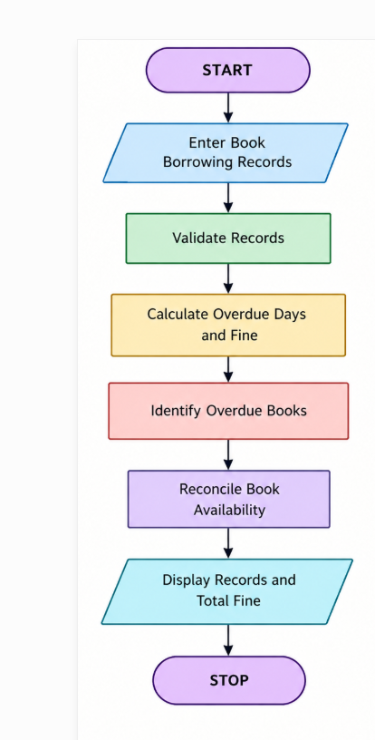

8. Explanation of the Program
- FINE_PER_DAY = 5 sets the fine at ₹5 for each overdue day.
- records stores borrowing details as tuples.
- seen_book_ids prevents duplicate book identifiers from being processed twice.
- Validation skips records with negative borrowing periods or return delays.
- Fine calculation multiplies overdue days by the daily fine rate.
- Availability reconciliation marks returned books as available and unreturned books as borrowed.
- total_fine accumulates fines from all valid returned records.
- overdue_count counts returned books with a positive delay.
9. Test Cases
Test case | Book ID | Return delay | Returned? | Expected fine | Availability
1 | B101 | 3 days | Yes | ₹15 | Available
2 | B102 | 0 days | Yes | ₹0 | Available
3 | B103 | 5 days | Yes | ₹25 | Available
4 | B104 | 0 days | No | ₹0 | Borrowed
5 | B105 | 1 day | Yes | ₹5 | Available
6 | B106 | -2 days | Yes | Invalid record | Not processed
10. Sample Output
====== LIBRARY BORROWING REPORT ======

Book ID: B101
Borrowing Period: 14 days
Return Delay: 3 days
Overdue Days: 3
Fine: Rs. 15
Availability: Available

Book ID: B102
Borrowing Period: 10 days
Return Delay: 0 days
Overdue Days: 0
Fine: Rs. 0
Availability: Available

Book ID: B103
Borrowing Period: 14 days
Return Delay: 5 days
Overdue Days: 5
Fine: Rs. 25
Availability: Available

Book ID: B104
Borrowing Period: 7 days
Return Delay: 0 days
Overdue Days: 0
Fine: Rs. 0
Availability: Borrowed

Book ID: B105
Borrowing Period: 14 days
Return Delay: 1 days
Overdue Days: 1
Fine: Rs. 5
Availability: Available

====== RECONCILIATION SUMMARY ======
Overdue Records: 3
Total Fine: Rs. 45

My Output
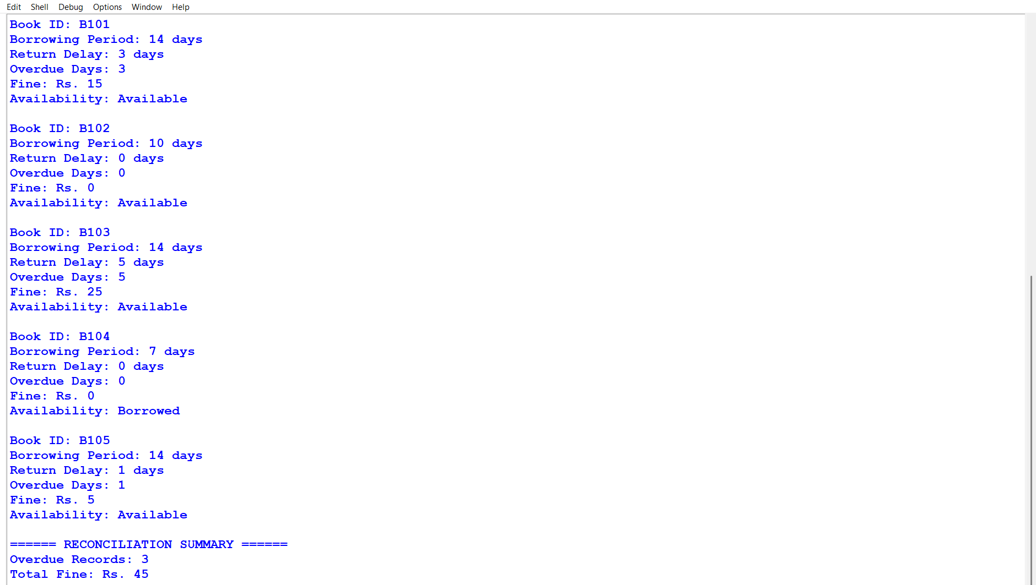

11. Conclusion
The Library Borrowing and Fine Reconciliation system demonstrates how Python tuples can store and process library borrowing records. It calculates fines for overdue books, identifies late returns, prevents duplicate book IDs from being counted twice, and reconciles book availability. This program reduces manual calculation errors and helps libraries maintain accurate borrowing and fine records.

